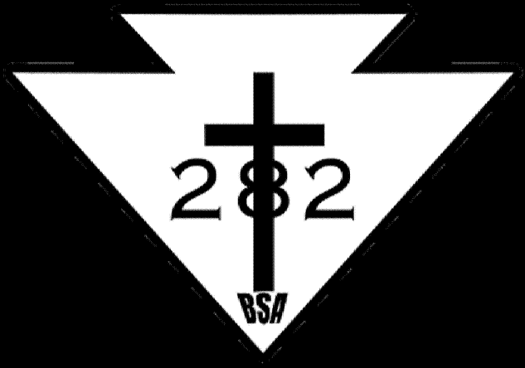

Parent’s Initials: (Charging ISA)

Name: ________________________________________________ ___________________________
Last Day to order:
Tuesday, April 24th
Don’t wait!

*Troop Hat
Adjustable Size $10 x _____ (Qty) = $ ________

*Troop T-Shirt: 100% Cotton Preshrunk. *Troop Wicking-T: 95% Polyester (great wicking)
Qty Subtotal Qty Subtotal Style V/C*
Adult Small $12 x _____ = $_______ Adult Small $15 x ___ = $_______ ________
Adult Medium $12 x _____ = $_______ Adult Medium $15 x ___ = $_______ ________
Adult Large $13 x _____ = $_______ Adult Large $15 x ___ = $_______ ________
Adult XL $13 x _____ = $_______ Adult XL $15 x ___ = $_______ ________
Adult XXL $14 x _____ = $_______ Adult XXL $17 x ___ = $_______ ________

*Troop Hooded Sweatshirt (80% COTTON!!!) *Troop Fleece
(CANNOT BE WORN AT CAMPOUTS OCT – JUNE) (Stays warm even when damp!)
Qty Subtotal Qty Subtotal
Adult Small $28 x _____ = $_______ Adult Small $31 x _____ = $_______
Adult Medium $28 x _____ = $_______ Adult Medium $31 x _____ = $_______
Adult Large $28 x _____ = $_______ Adult Large $31 x _____ = $_______
Adult XL $31 x _____ = $_______ Adult XL $35 x _____ = $_______
Adult XXL $31 x _____ = $_______ Adult XXL $35 x _____ = $_______

*Troop Polo Shirt (Adults Only) *Special Logo Only ($6 for small embroidered logo)
Please describe provided article of clothing and location and size of logo.
Qty Subtotal
Adult Small $23 x _____ = $_______
Adult Medium $23 x _____ = $_______ _______________________________________________
Adult Large $23 x _____ = $_______ _______________________________________________
Adult XLarge $27 x _____ = $_______ _______________________________________________
Adult XXLarge $27 x _____ = $_______ _______________________________________________

Total Payment: $__________

All charges will be made to the Scout’s Individual Scout Account (ISA). Return this form to MRS. ADDISON on or before APRIL 25, 2018 (laddison6@gmail.com) *V=V-Neck (ladies), C=Crew Neck (Unisex)
Troop Cotton T-Shirt (Model 2000)

Screen printed front left and back. 6.1-ounce 100% cotton (preshrunk) Seamless double-needle collar Double-needle sleeves and hem Taped neck and shoulders. Great value and soft feel of cotton. (Recommended for summer camping.)

Troop Hooded Sweatshirt (Model 9500)

Screen printed front left and back. This is a popular hooded sweatshirt that is great for wearing to Troop meetings, summer camp and school. It is a warm, great feel of cotton. However, wearing this sweatshirt is discouraged by the Troop because once it gets wet, it is cold! 9.5-ounce 80/20 cotton/poly fleece. Double-needle stitching. 2x1 rib knit cuffs and waistband with spandex. Double-lined hood with dyed-to-match drawcord. Set-in sleeves. Front pouch pocket.

(Only for Summer Camping. NOT ALLOWED FOR CAMPOUTS OCTOBER – JUNE!)
Troop Wicking Polyester T-Shirt (Model Zoom 2.0)
Screen printed front left and back. Choices are the crew neck or the v-neck. These shirts consist of a Dry Excel™ polyester knit that is both moisture wicking and odor-resistant. The v-neck t-shirt is semi-fitted and tagless. The crew neck is more of a loose fit and tagless. It is a very lightweight shirt that dries easily and weighs next to nothing!

Fleece (Model F217):

Embroidered Troop Logo on front left only. This fleece sweatshirt is encouraged instead of the hooded sweatshirt. This is a new fleece for the Troop. What’s different: It is slightly heavier, zippered pockets, but does not have brand name R-Tek fleece. However, it is at a much lower price! This exceptionally soft fleece jacket will keep you warm during everyday excursions and it's offered at an unbeatable price. 13.8-ounce 100% polyester. Twill-taped neck. Reverse coil zipper. Zipper garage. Bungee cord zipper pulls. Front zippered pockets. Interior pockets. Open cuffs. Open hem with drawcord and toggles for adjustability.

(Recommended for warmth in the summer and additional layer in the winter!)

Polo (Model K500):

Embroidered Troop Logo on front left only. FOR ADULT SCOUTERS ONLY. Scouter – show that you are with our Troop around camp and at meetings when not in a Class A BSA shirt. An enduring favorite our comfortable classic polo is anything but ordinary. With superior wrinkle and shrink resistance a silky soft hand. 5-ounce 65/35 poly/cotton pique. Flat knit collar and cuffs. Metal buttons with dyed-to-match plastic rims. Double-needle armhole seams and hem.

Cap (Model CP85):

Embroidered Troop Logo on front. Adjustable cap. A tremendous value this cap complements your logo with its contrast sandwich bill. Fabric 100% cotton twill Structure Structured Profile Mid Closure Hook and loop.

Old Info:
Troop Polyester T-Shirt (Model ST700)

Screen printed front left and back. Finally a t-shirt that performs as long as you do! Our new Ultimate Performance Crew has a soft cottony hand but effectively wicks sweat so you stay cooler and drier while running training or just lounging around. Raglan sleeves with flatlock stitching make for easy movement. An anti-pill finish keeps this high performer looking great. 5-ounce 95/5 poly/spandex. Loose athletic fit. Double-needle stitching throughout. Raglan sleeves.

(Great base layer for winter camping, very cool in the summer.)

