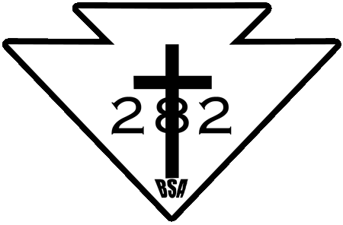

Summer into Fall Outing Calendar
July 15th to 21th – Camp Parsons
July 28th – August 4th – Cycling @ San Juan Isl.
Look for updates posted via the Troop 282 calendar.

What do I need to do to go on the monthly camping trips with my Scout and Troop 282?
Step #1
Take “Youth Protection Training” Online @ http://www.scouting.org/Training/YouthProtection.aspx
Be sure to print the certificate and give a copy to Mrs. Darling.
Step #2
Register as a Boy Scout Adult
See Mrs. Darling for Application
Step #3
Complete part A and Part B on the BSA Medical Form.
Be sure to copy the form and give a copy to Dr. Saxman
Step #4
- Complete the Position-Trained-Requirements for Assistant Scoutmaster on the attached sheet.
- Be sure to use Scout Book (https://www.scoutbook.com/), using My Trainings section of your Adult Scouter account.
- Use (https://my.scouting.org/) for all your trainings, making sure that you have utilized your Adult Scouter BSA id number.
- Additional information will be taught on Troop Campouts.
Step #5
Receive your “Trained” patch to wear on your uniform!!!

